Arboretum Site Map
Made using PowerPoint

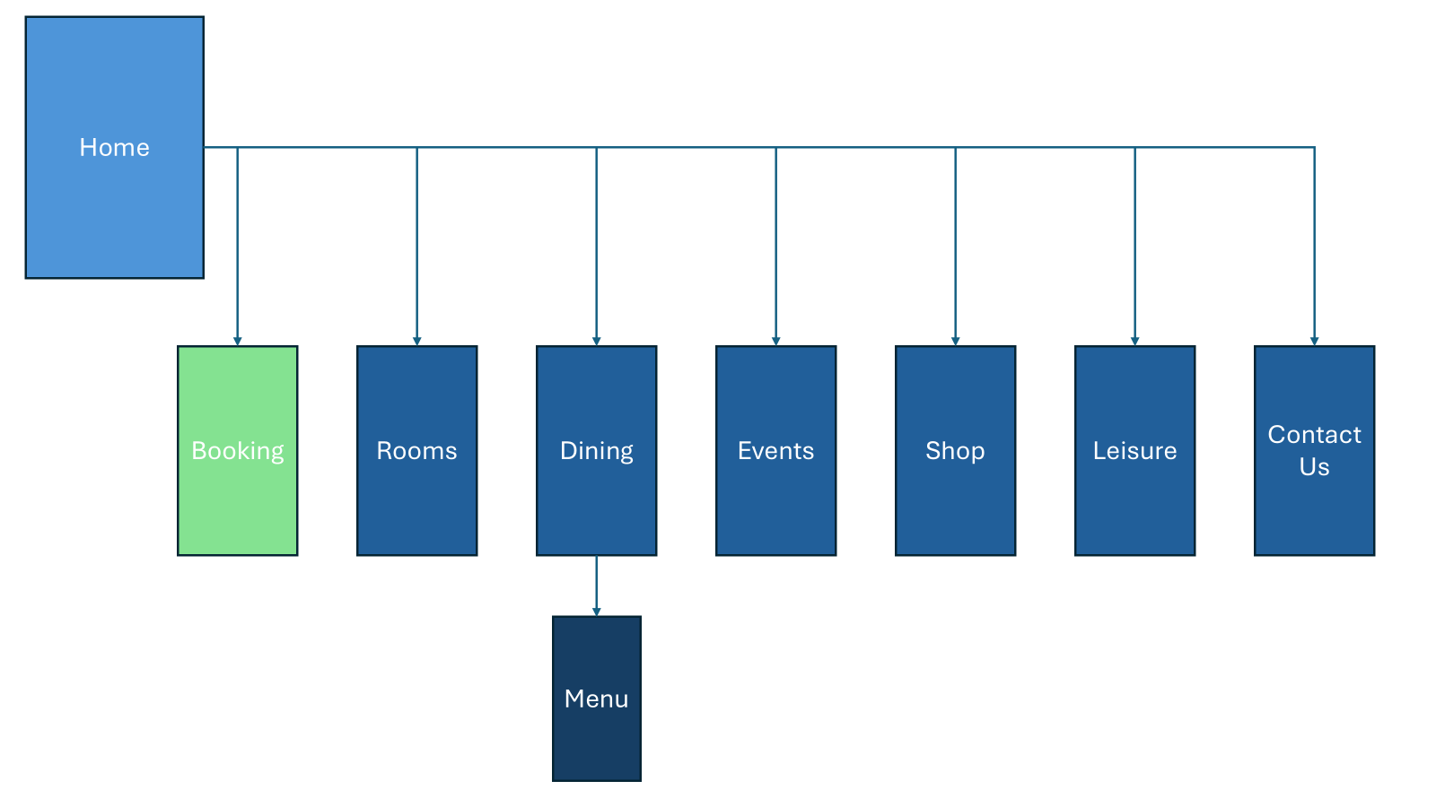
*Leisure renamed to Facilities.
- ‘Book Now’ Button takes you to the ‘Booking’ page, button accessible on all pages except menu.

